**Ideation Phase**

**Empathize & Discover**

|  |  |
| --- | --- |
| Date | 12 April 2025 |
| Team ID | SWTID1743607402 |
| Project Name | ShopEZ: E-commerce Application |
| Maximum Marks | 4 Marks |

**Empathy Map Canvas:**

An empathy map is a simple, easy-to-digest visual that captures knowledge about a user’s behaviours and attitudes.

It is a useful tool to helps teams better understand their users.

Creating an effective solution requires understanding the true problem and the person who is experiencing it. The exercise of creating the map helps participants consider things from the user’s perspective along with his or her goals and challenges.

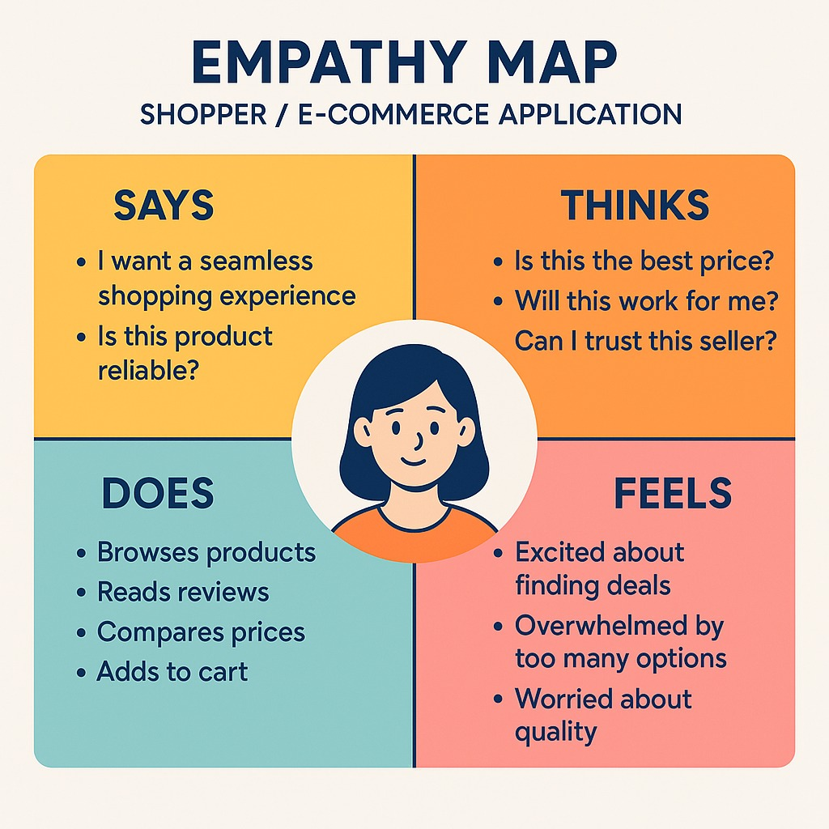

# Empathy Map for ShopEZ User (Online Shopper)

## SAYS

- I want a seamless and hassle-free shopping experience.  
- This product looks interesting, but I’ll check reviews first.  
- I hope the checkout is quick and easy.

## THINKS

- Will this product be worth the price?  
- Can I trust this seller and the platform?  
- Are there better alternatives elsewhere?  
- What if the product quality isn't as described?

## DOES

- Browses different categories.  
- Filters products by price and ratings.  
- Compares multiple products.  
- Adds items to the cart and removes them repeatedly before deciding.  
- Shares product links with friends or family for opinions.

## FEELS

- Excited when finding a great deal.  
- Hesitant while entering payment details.  
- Frustrated by delays or lack of stock.  
- Relieved after receiving a good-quality product on time.